**Advanced Joins - Part 13**

**In this video session we will learn about**  
1. Advanced or intelligent joins in SQL Server  
2. Retrieve only the non matching rows from the left table  
3. Retrieve only the non matching rows from the right table  
4. Retrieve only the non matching rows from both the left and right table  
  
**Before watching this video,**[**please watch Part 12 - Joins in SQL Server**](http://csharp-video-tutorials.blogspot.com/2012/08/joins-in-sql-server-part-12.html)  
  
  
  
  
  
  
  
**Considers Employees (tblEmployee) and Departments (tblDepartment) tables**  
  
**Employee Table (tblEmployee)**  
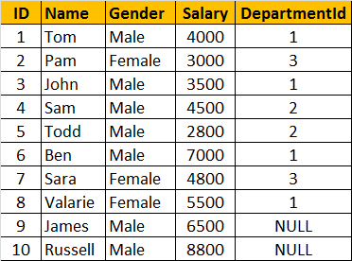  
  
**Departments Table (tblDepartment)**  
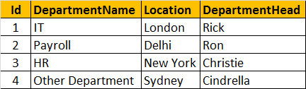  
  
**How to retrieve only the non matching rows from the left table. The output should be as shown below:**  
https://1.bp.blogspot.com/-7vt-QpC4mZ8/UDDiiSTHcUI/AAAAAAAAAPo/5x1-GB7B9VM/s1600/Only+Left+Table+Rows.png  
  
**Query:**  
SELECT       Name, Gender, Salary, DepartmentName  
FROM           tblEmployee E  
LEFT JOIN   tblDepartment D  
ON                 E.DepartmentId = D.Id  
WHERE        D.Id IS NULL  
  
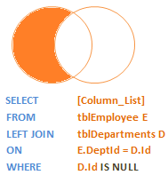  
  
**How to retrieve only the non matching rows from the right table**  
https://1.bp.blogspot.com/-ycu3SCB-mn0/UDDj12WVhYI/AAAAAAAAAP4/WoJn5XGOlJc/s1600/Only+Right+Table+Rows.png  
  
**Query:**  
SELECT         Name, Gender, Salary, DepartmentName  
FROM             tblEmployee E  
RIGHT JOIN    tblDepartment D  
ON                   E.DepartmentId = D.Id  
WHERE          E.DepartmentId IS NULL  
  
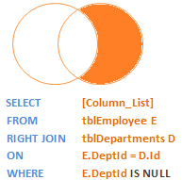  
  
**How to retrieve only the non matching rows from both the left and right table. Matching rows should be eliminated.**  
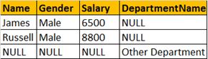  
  
**Query:**  
SELECT         Name, Gender, Salary, DepartmentName  
FROM              tblEmployee E  
FULL JOIN      tblDepartment D  
ON                   E.DepartmentId = D.Id  
WHERE          E.DepartmentId IS NULL  
OR                   D.Id IS NULL  
  
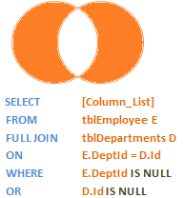

[Email This](https://www.blogger.com/share-post.g?blogID=6082652835152798567&postID=2981854784058707899&target=email)[BlogThis!](https://www.blogger.com/share-post.g?blogID=6082652835152798567&postID=2981854784058707899&target=blog)[Share to Twitter](https://www.blogger.com/share-post.g?blogID=6082652835152798567&postID=2981854784058707899&target=twitter)[Share to Facebook](https://www.blogger.com/share-post.g?blogID=6082652835152798567&postID=2981854784058707899&target=facebook)[Share to Pinterest](https://www.blogger.com/share-post.g?blogID=6082652835152798567&postID=2981854784058707899&target=pinterest)